Around Our Community
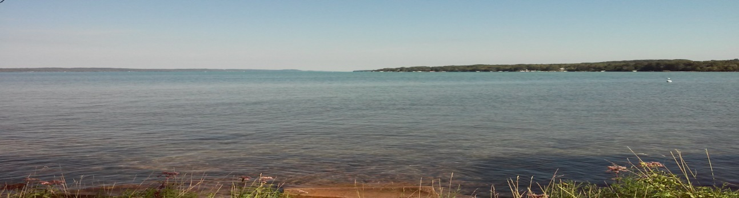
Volume I Helena Township 8751 Helena Road Alden, Mi 49612 231 331-4643 helena@torchlake.com

We hope that all are well, and staying safe while living in and visiting our
beautiful township. No one could have predicted that after six months
of following stay at home, distancing and mask orders, we would still be
limited on enjoying all the amenities that we have to offer here in Helena
Township.

We have all missed several annual events, such as the Memorial Day Parade,
Alden Days, Alden Men’s Rummage Sale, Farmer’s Market, Cherry Pie Sales,
Women’s Rummage/Bake Sale, shopping in all of our stores, and of course
the always popular Evening Strolls and music. We were however, able to
enjoy the 4th of July Fireworks, thanks to some very generous donations.

Your Township Board has been hard at work to complete many projects
within our Five Year Plan, including the resurfacing of Helena Rd. and
SE Torch Lake Drive. Some projects have been on a waiting schedule
as companies catch up the back log of work they experienced due to being
closed during the stay at home orders. Hopefully many will be completed
before snow flies! Check inside to see pictures of your tax dollars at work.

Helena Township Board Township Committees/Services Community Organizations

Rick Teague, Supervisor Board of Review Alden Volunteers
David Peterson, Clerk Parks and Rec DABA
Catherine Rice, Treasurer Planning Commission The Boys of Summer
Bonnie Robbins, Trustee Road Committee The Friends of the Library
Butch Bartz Sr., Trustee South Torch Fire and Rescue
Zoning Board of Appeal

1

Parks/Accesses/Roads

Completed
*Removed Invasive Locust Bush from TC
*Pickleball Court
Handicap Accessibility TC Park
*Well/WaterFountain/Public Restroom
Repairs TC Park
*New Post and Signage at Mary’s Beach
*Update Coy Mtn. Trails and Signage
*Purchase of new Downtown Street Lights with Special Flower/Signage inserts
*Lighthouse/Repaired benches at Launch Site
* Approved Depot/Train Sections
Blacktop Entry/Exit
*Annual Community Trash/Cleanup Day
*Gravel/Blacktop Entry at Ball Park
*Preserve and Maintain Public Accesses

Scheduled
*Repair of Handicap Dock at Launch
*New Fence Section at Depot
*New Fence Section/Signage at Ball Park
*Prioritize/Repair/Resurface Twp. Roads

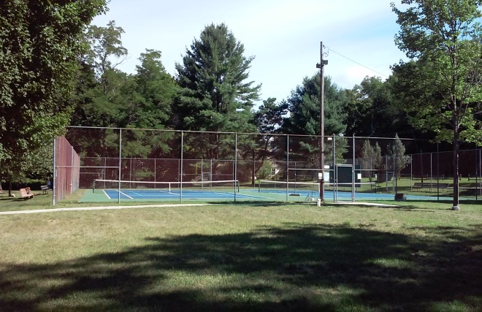
Tennis Courts/Pickleball Courts

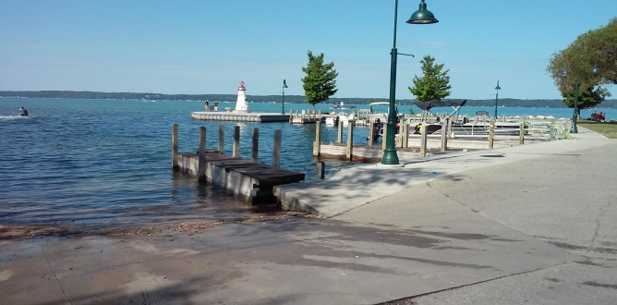
Docks/Launch/Public Access
2
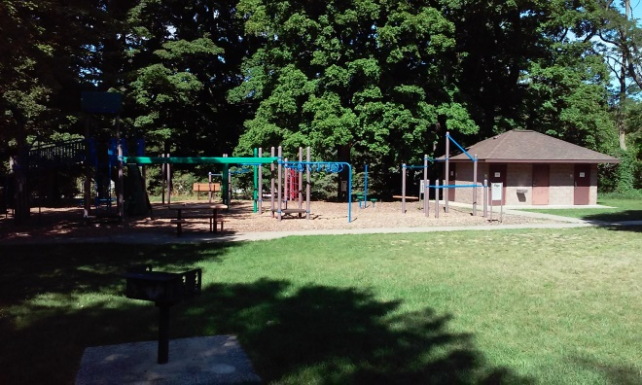
Tennis Court Playground

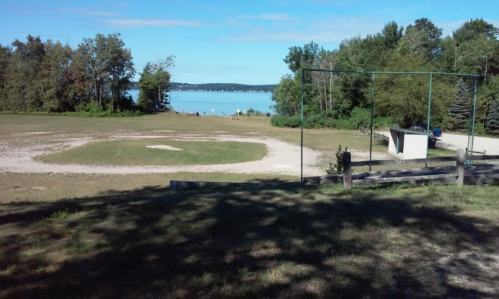
Ball Park/Public Access

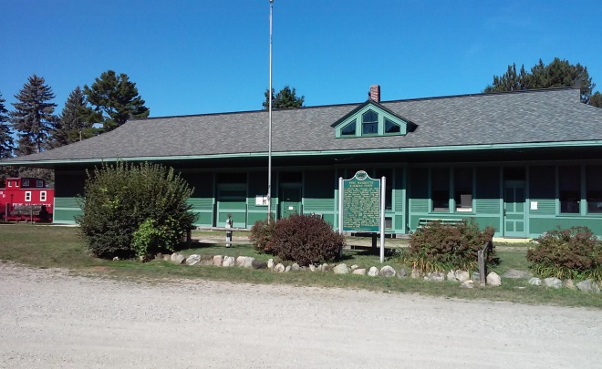
Depot Park

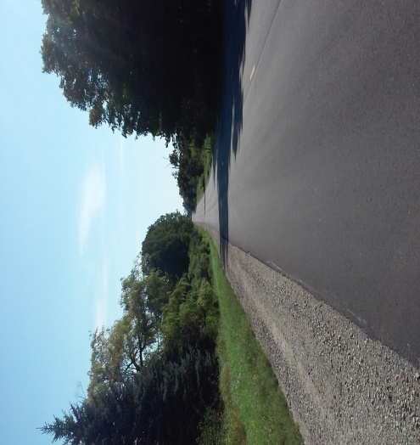
Helena Road

Community Center

Completed
*Resurfacing/Striping of Parking Lot
*Energy Saving Daylight Sky Lights
*Air Conditioning
*Whole Building Generator
*Pickleball Court
*New Post and Mailbox to USPS Code
*New Community Center/Library Sign
*Repair of Boilers
*Replacement of Outside Faucet
*Painting
*Stripping and Resealing of Floors
*Sanitizing Products and Stations throughout Building
*Plexiglass Walls, Gloves, Masks for Voter Stations/Safety Code
*Handicap Accessible Doors

Scheduled
*Gravel for Back Parking Lot
*Cages for Air Conditioners
*Complete Remodel of Kitchen

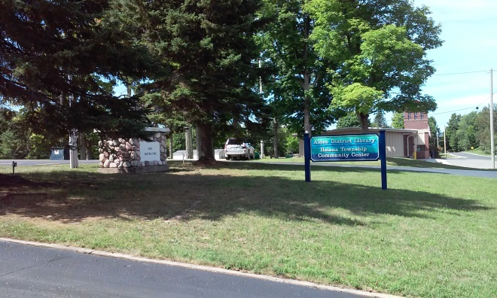Community Center
The Helena Township Board will continue to work within a balanced taxpayer’s dollars budget not only to maintain our assets, but to enhance our beautiful Village of Alden.

Cemetery

Completed
*Removal Dead Trees/Brush
Spring Cleanup
*Flags Purchased and Placed for Veteran’s
*Garbage Receptacles
*New Flag

Scheduled
*Remove old Split Rail Fence
*Painting of Two Outbuildings
*Removal of Additional Dead Trees
*Fall Cleanup Brush/Leaves

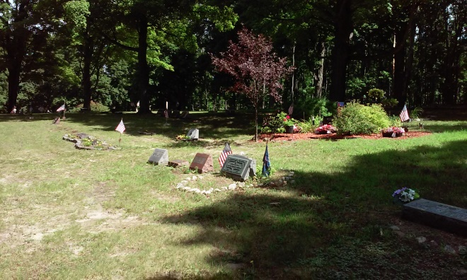
Cemetery

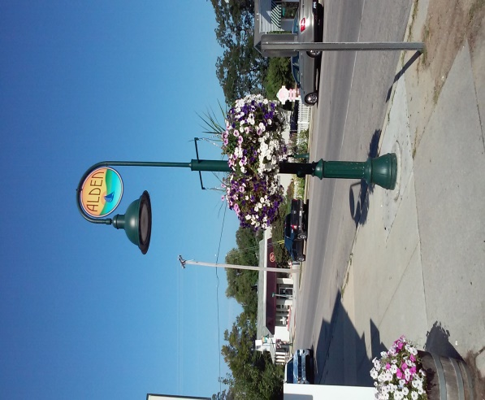
Downtown Alden

3

